**Enrolment System - Report Template**

|  |  |
| --- | --- |
| Student ID | Name |
| 001187879 | Mau Patel |

**Part I - Gathering and Documenting Requirements**

1. **Technical requirements:**

|  |  |
| --- | --- |
| **Requirement ID** | **Description** |
| ***RE01*** | ***Legacy UI must be maintained*** |
| RE02 | Cloud based multiuser application. |
| RE03 | Accessible by different users at various locations. |
| RE04 | Must be menu driven system. |
| RE05 | Must be cloud based database. |

1. **Higher Level Use Case Model (Add your model here)**

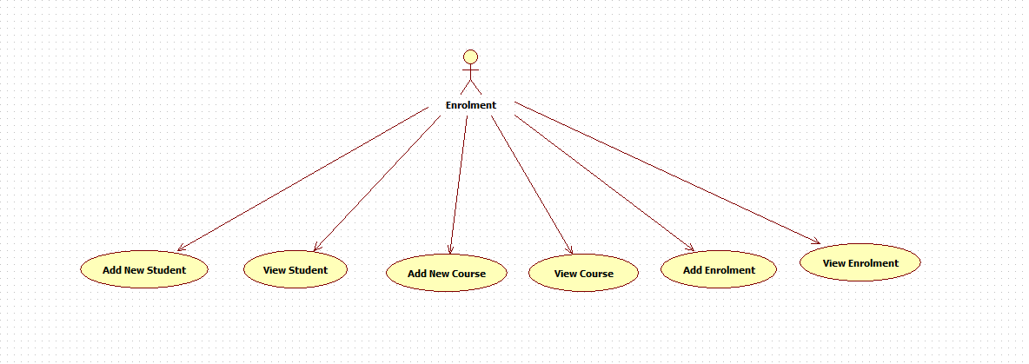

1. **Classes and relationship (Add class diagrams here)**

1. **List of services to be implemented**

|  |
| --- |
| **1 View Enrolment** |
| **2 Add Enrolment** |
| **3 Add New Student** |
| **4 View Student** |
| **5 View Course** |
| **6 Add Course** |
|  |
|  |

1. **Technical Considerations:**

|  |  |
| --- | --- |
| **Considerations** | **Response** |
| 1. Hosting. Compare a cloud solution vs private hosting. What is the most suitable option?   Identify three factors to consider when you are making this decision. | Cloud solution would be the most suitable option because it allows developers create and run apps, store data without the need of on-premise data centers and the up keep of other hardware resources.  Factors to consider:   1. Security 2. Scalability – cloud hosting can easily handle high web traffic by utilising additional recourses in the cloud. 3. Cost- Cloud hosting allows for flexible pricing structure, so you only need to pay for the server resources. |
| 1. Cloud Service Model   Identify a suitable cloud service model for this application.   List three main characteristics of the identified model. | The Platform as a Service (PaaS) model is suitable for this application  Characteristics of PaaS:  1. Provides a development environment with tools, frameworks, and middleware.  2. Supports rapid application development without managing the underlying infrastructure.  3. Scalable architecture for dynamic resource allocation. |
| 1. Service Provider   If your choice is a cloud service provider, which option would you choose from AWS, Google Cloud or Azure? Justify your choice (maximum 50 words). | Microsoft Azure would be the best choice because it integrates well with Windows Communication Foundation (WCF) and provides IIS-based cloud hosting for seamless deployment. Azure also offers strong enterprise security, AI-driven analytics, and compliance with global regulatory standards. |
| 1. Database (Max 100 words)   Identify a suitable alternative multi-user database to local SQL Server. Justify your choice (maximum 50 words). | Azure SQL Database is a suitable alternative because it is cloud-based, fully managed, and scalable. It offers built-in security, automated backups, and high availability. Azure SQL ensures smooth integration with WCF applications, reducing database administration efforts while maintaining performance and reliability. |
| 1. IDE   Identify a suitable development environment and two tools to be used for the development. | Visual Studio is a suitable IDE for WCF development.  Tools to be used:  1. WCF Test Client – Used for testing and debugging WCF services.  2. Service Configuration Editor – Helps configure WCF services and manage service endpoints. |
| 1. Architecture and Framework   Identify a suitable cloud computing application architecture and a framework to be used for the cloud computing application. | Architecture: Service-Oriented Architecture (SOA) – WCF follows SOA principles, providing loosely coupled services.  Framework: .NET Framework with WCF – It allows seamless development and hosting of web services with strong security, interoperability, and reliability. |
| 1. Uptime strategy (Max 100 words)   Identify and develop an uptime strategy for the services. Your strategy must include use of availability zones and uptime estimate based service providers SLA | The uptime strategy will utilize multi-region deployment with Azure Availability Zones to ensure redundancy. Load balancing and auto-scaling will handle traffic spikes. According to Azure’s SLA, 99.95% uptime is guaranteed. Regular monitoring, automated failover mechanisms, and disaster recovery plans will further improve availability and minimize downtime. |

**Part III - Testing the Cloud Application**

**Test Plan**

**Testing Services using WCF Client**

|  |  |  |  |  |
| --- | --- | --- | --- | --- |
| **Service** | **Input** | **Expected Output** | **Actual Output** | **Comments** |
| **1 View Enrolment** | **Invoke** | **Display all Enrolments** | **Displayed all Enrolments** | **Pass** |
| **2 Add Enrolment** | **StudentID: 8**  **CourseID: 5**  **Grade: Fail** | **StudentID: 8**  **CourseID: 5**  **Grade: Fail** | **StudentID: 8**  **CourseID: 5**  **Grade: Fail** | **Pass** |
| **3 Add New Student** | **StudentName: Terry**  **DateEnrolled: 13/09/24** | **StudentID: 8**  **StudentName: Terry**  **DateEnrollned: 13/09/24** | **StudentID: 8**  **StudentName: Terry**  **DateEnrollned: 13/09/24** | **Pass** |
| **4 View Student** | **Invoke** | **Display all students** | **Displayed all students** | **Pass** |
| **5 View Course** | **Invoke** | **Display all courses** | **Displayed all courses** | **Pass** |
| **6. Add Course** | **courseName: Introduction to Python**  **Cost: $150** | **CourseID: 5**  **CourseName: Introduction to Python**  **Cost: $150** | **CourseID: 5**  **CourseName: Introduction to Python**  **Cost: $150** | **Pass** |
|  |  |  |  |  |

**Screenshots:**

1. **Student Service**
2. **Get All Students**

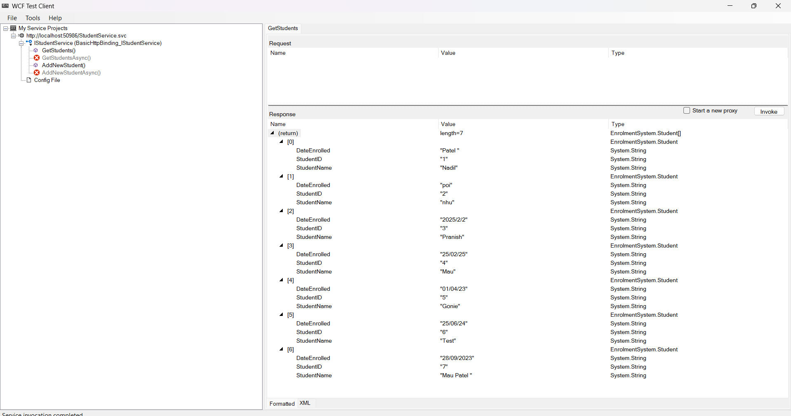

1. **Add New Student**

1. **Course Service**
2. **View All Courses**

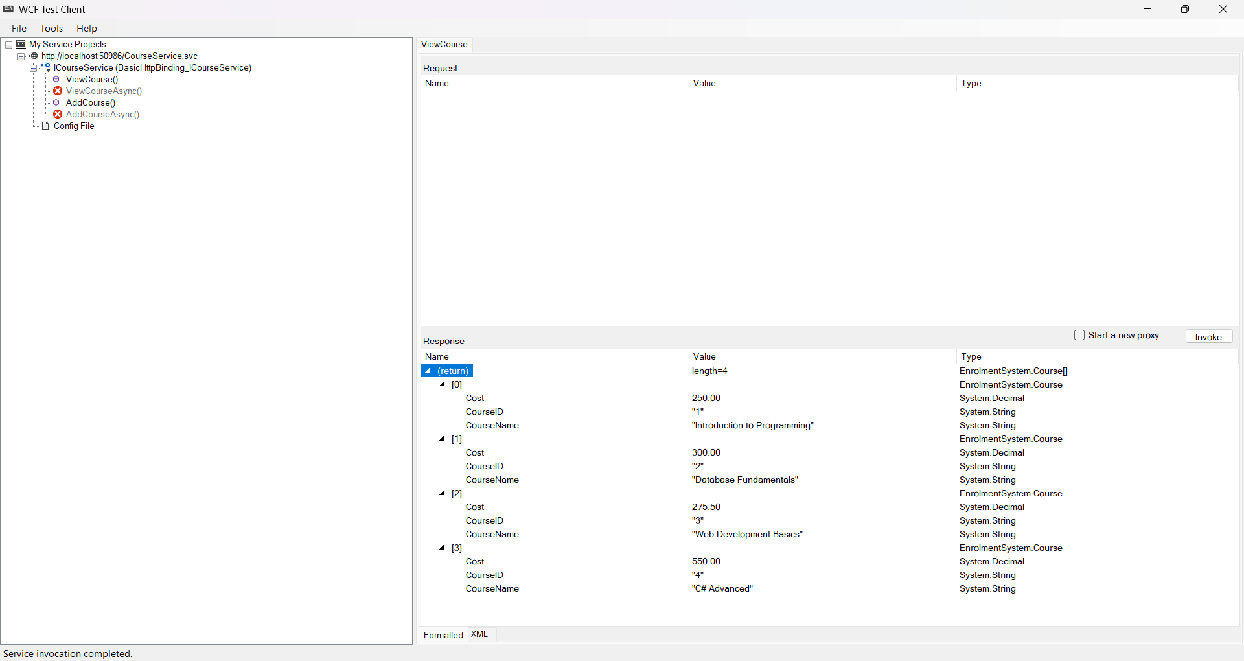

1. **Add A Course**

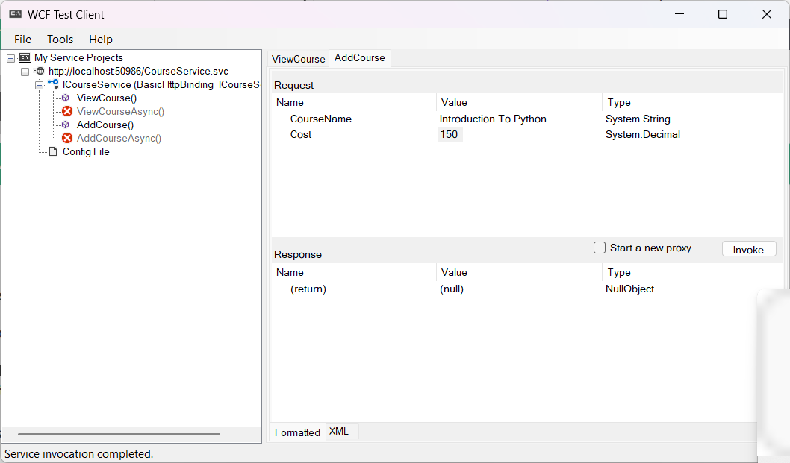

1. **Enrolment Service**
2. **View Enrolments**

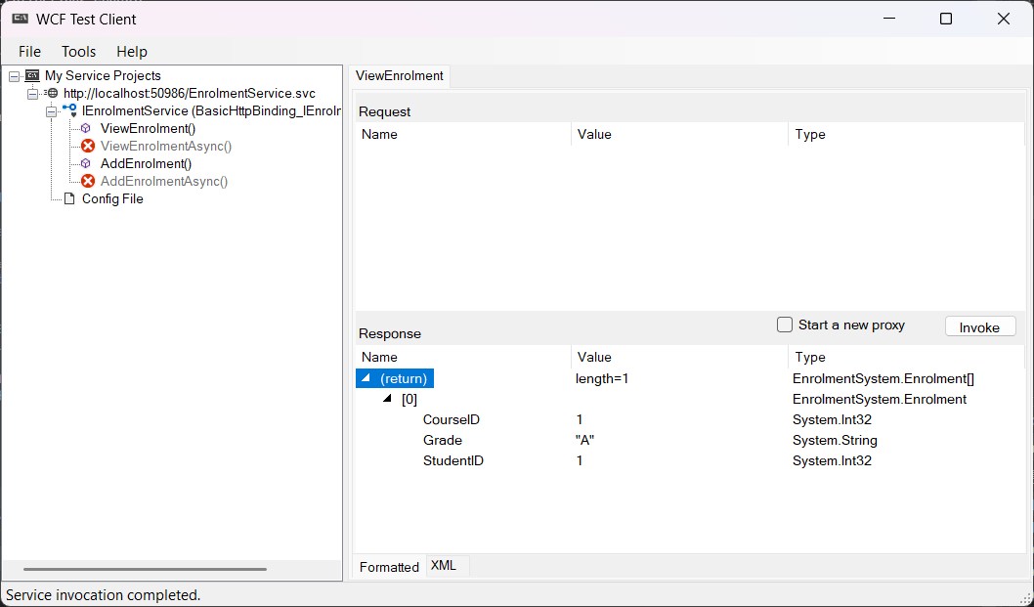

1. **Add Enrolment**

**Part IV - Deploying /Publishing Services to Azure**

**Steps - Deploying /Publishing your services**

**Steps for publishing to azure you can take screenshots or write down the steps**

1. **Right click on your project and select publish**

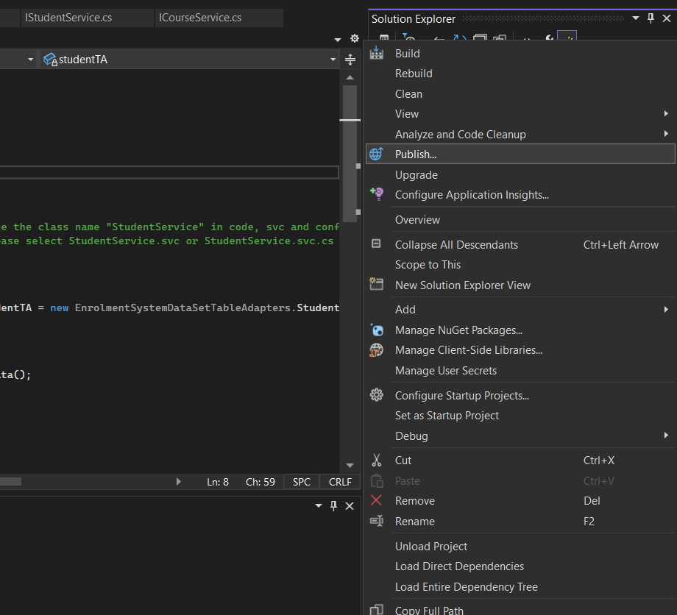

1. **Select Azure – Host application to the Microsoft cloud. Click Next**

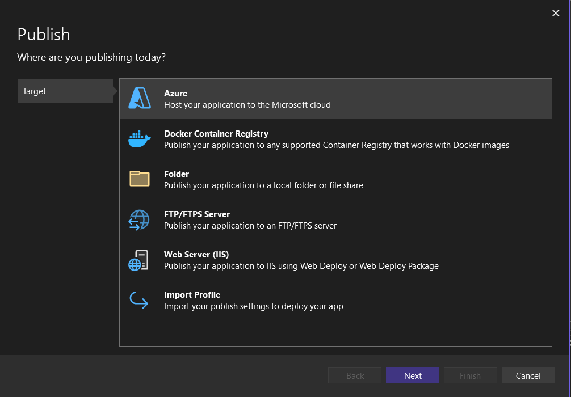

1. **Select Azure App Service (Windows). Click Next.**

1. **Click New Profile and Sign in with your Microsoft account and then. Click Create new.**

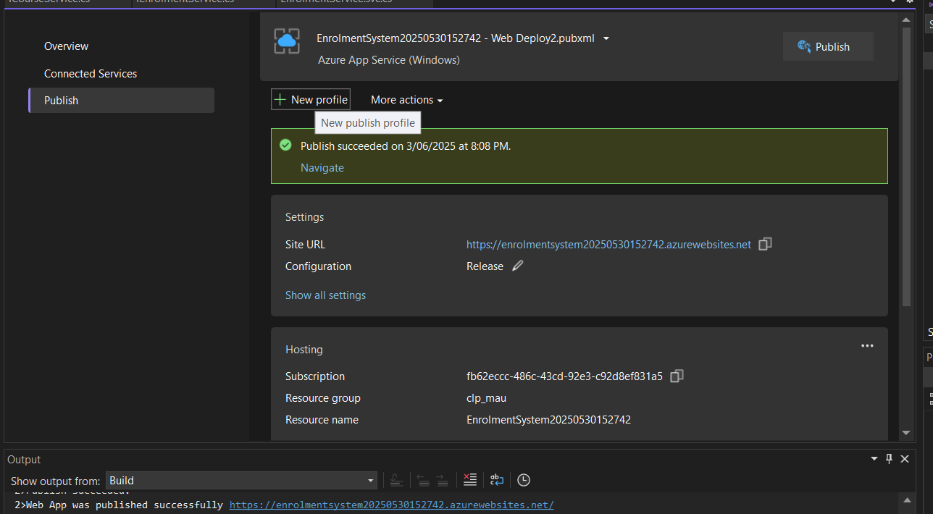

1. **Name App service instance, enter Azure subscription name, select resource group and hosting plan**

1. **You should see an existing Azure App Service. Select and click finish**

1. **Click publish. App Service is now published to Azure. A screenshot of a computer

   AI-generated content may be incorrect.**
2. **The web application is now running**

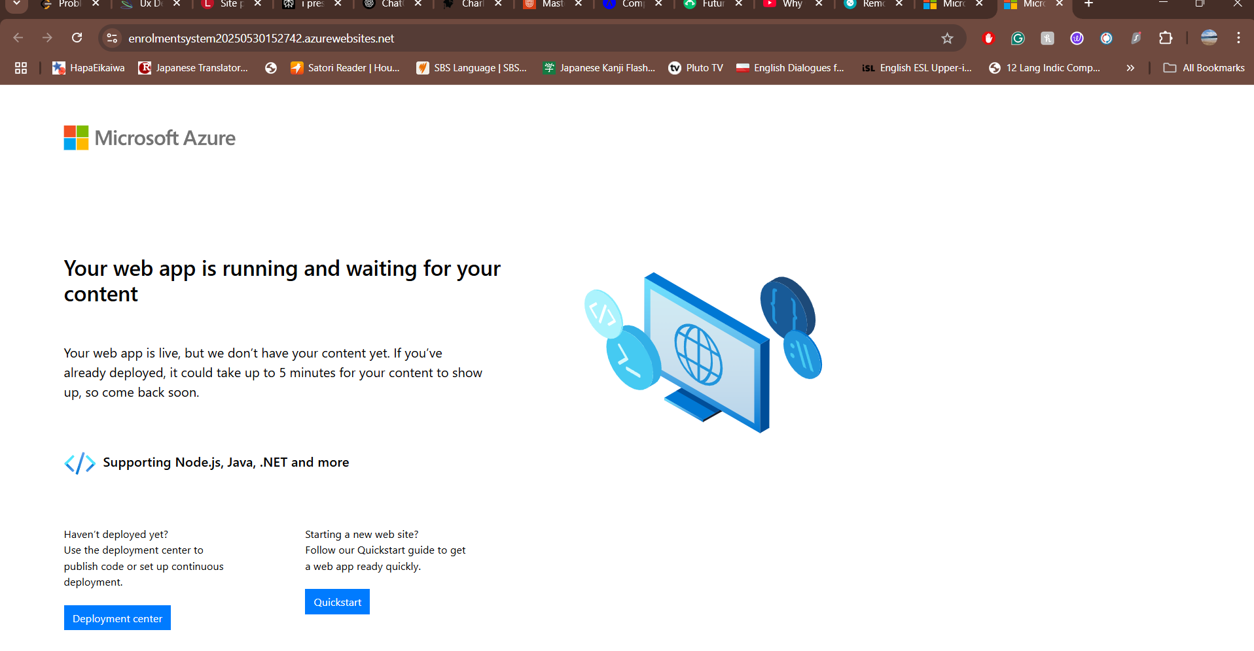

|  |  |
| --- | --- |
| **URL** | **https://enrolmentsystem20250530152742.azurewebsites.net** |

**Testing Services using Windows Client**

| **Service** | **Input** | **Expected Output** | **Actual Output** | **Comments** |
| --- | --- | --- | --- | --- |
| **AddStudent** | **StudentName="John", Date="2024-01-01"** | **Student added and listed in ViewStudents** | **Student added and appears in list** | **Pass** |
| **GetStudents** | **(None)** | **List All students** | **Display all correctly** | **Pass** |
| **AddCourse** | **CourseName="REST API", Cost=575.00** | **Course added and listed** | **Course appears in ViewCourses list** | **Pass** |
| **ViewCourses** | **(None)** | **List of all courses** | **Courses displayed correctly** | **Pass** |
| **AddEnrolment** | **StudentID=5, CourseID=4, Grade="B"** | **Enrolment saved** | **Enrolment appears in ViewEnrolments** | **Pass** |
| **ViewEnrolments** | **(None)** | **List of enrolments with student + course + grade** | **Displays all correctly** | **Pass** |

**Screenshots:**

1. **Testing Student Service**

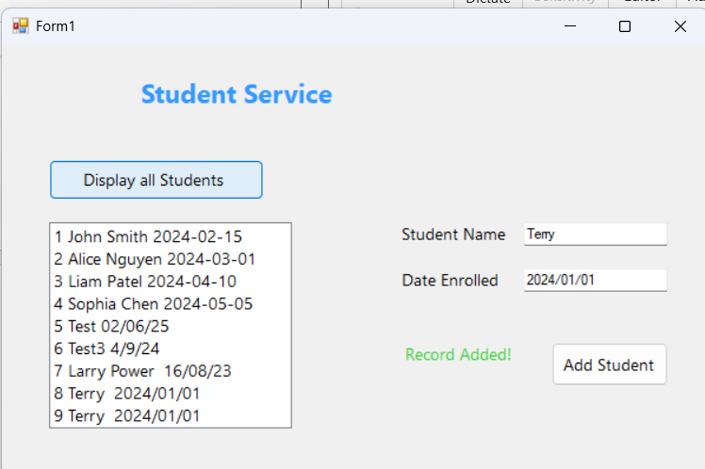

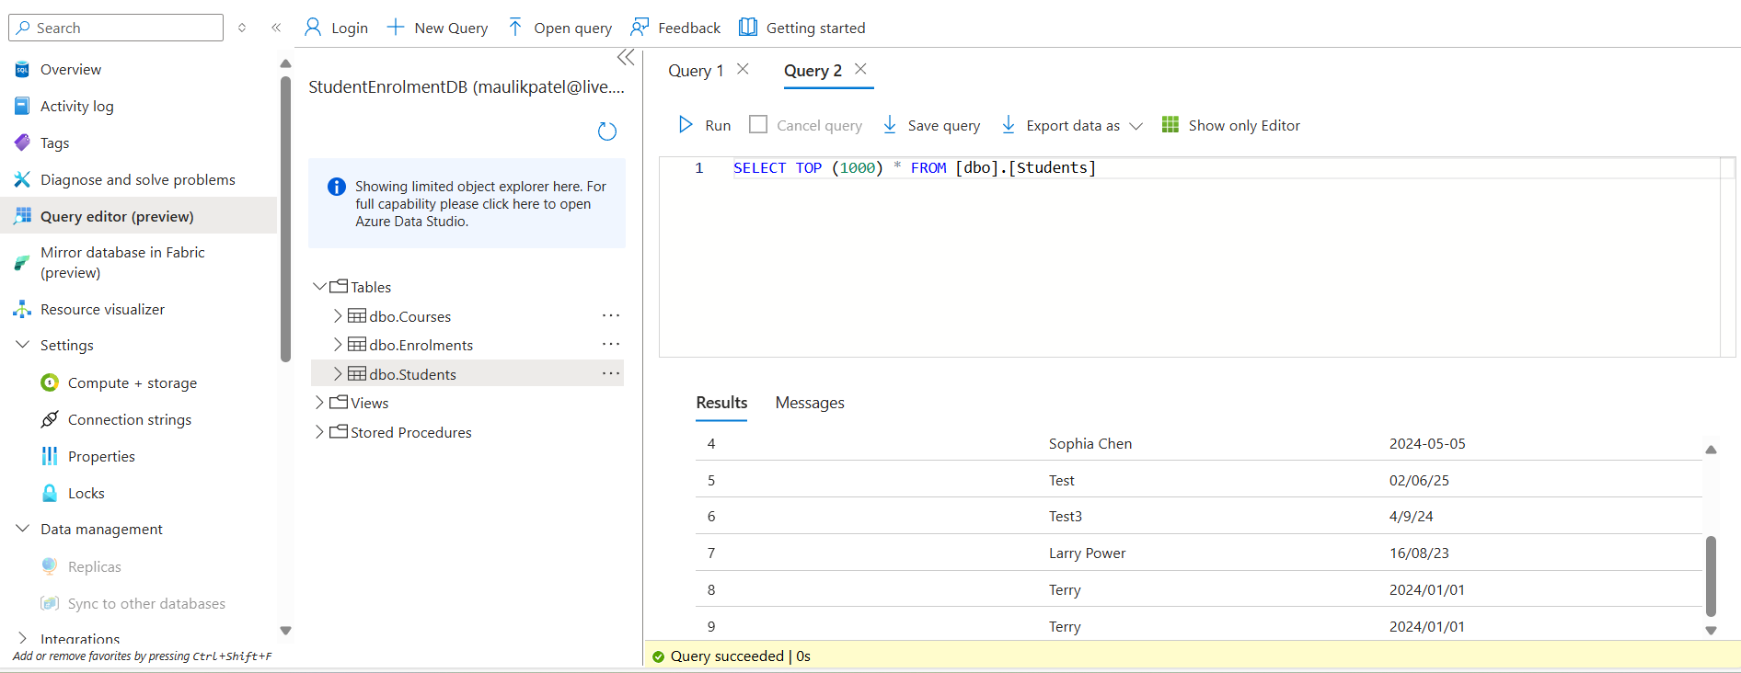

1. **Testing Course Services**

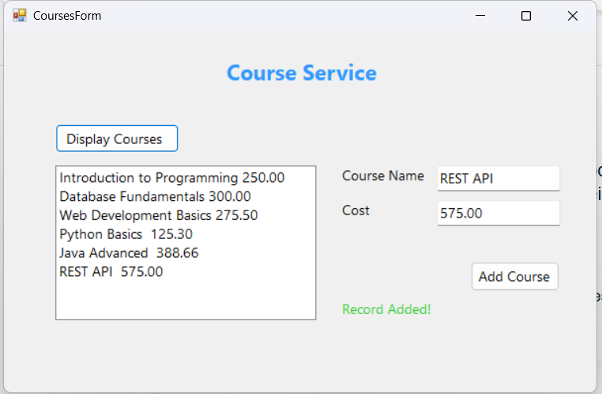

1. **Testing Enrolment Service**

